7COM1079-0901-2025 - Team Research and Development Project

Final report title: Student Alcohol Consumption

Group ID: A81
Dataset number: DS240
Prepared by:
Gopi Borra – 24072772
Nikhil Reddy Bokkala – 24089907
Janaki Ram Krishna Kollu – 23085568
Surya Pendyala – 24090841
Mahesh Babu Somarouthu - 24074537

University of Hertfordshire
Hatfield, 2025

1
Table of Contents
1. Introduction 3
1.1 Problem Statement and Research Motivation 3
1.2 The Data Set 3
1.3 Research Question 3
1.4 Null and Alternative Hypotheses (H₀ / H₁) 4
2. Background Research 5
2.1 Research Papers 5
2.2 Why the Research Question Is of Interest 5
3. Visualisation 6
3.1 Appropriate graphs for the RQ output of an R script 6
3.2 Additional information relating to understanding the data 7
3.3 Useful information for the data understanding 7
4. Analysis 8
4.1 Statistical test used to test the hypotheses and output 8
4.2 Hypothesis decision and interpretation based on the p-value 8
5. Evaluation – Group’s Experience at 7COM1079 9
5.1 What went well 9
5.2 Points for improvement 9
5.3 Group’s time management 9
5.4 Project’s overall judgement 10
5.6 Comment on the GitHub log output 10
6. Conclusions 11
6.1 Results explained 11
6.2 Interpretation of the results 11
6.3 Implications, limitations, and future work 12
7.References 12
8. Appendices 13

2

1. Introduction

1.1 Problem Statement and Research Motivation

Teenagers drinking alcohol is a big public health problem because it can lead to bad academic, social, and health outcomes. Drinking habits that start in high school can last into adulthood, which raises the risk of long-term harm. Prior studies suggest that alcohol consumption patterns may differ by gender, with male students frequently exhibiting elevated levels of alcohol use, especially on weekends when social drinking is prevalent. To create effective prevention strategies and school-based interventions, it is important to understand these behavioural differences. Examining gender disparities in weekend alcohol consumption can yield significant insights for educators and policymakers (Kuntsche et al., 2011).

1.2 The Data Set

This research utilises the Student Alcohol Consumption dataset from the UCI Machine Learning Repository, obtained through Kaggle. There are 395 records in the dataset of Portuguese high school students who are taking maths classes. It has demographic, academic, and behavioural factors. This analysis examines student gender (sex) and weekend alcohol consumption (Walc), assessed using a five-point ordinal scale. The dataset is appropriate for statistical analysis and has been extensively utilised in educational research.

1.3 Research Question

This study aims to investigate whether weekend alcohol consumption differs between male and female students. Specifically, the research question is:
Is there a difference in the mean weekend alcohol consumption (Walc) between male and female students?
This question follows a comparison-of-means approach using inferential statistical analysis.

3

1.4 Null and Alternative Hypotheses (H₀ / H₁)

To respond to the research inquiry, the subsequent hypotheses are established. The null hypothesis posits that gender does not influence weekend alcohol consumption among students. On the other hand, the alternative hypothesis says that gender is related to differences in consumption levels.

Null hypothesis (H₀): There is no difference in the mean weekend alcohol consumption (Walc) between male and female students.
Alternative hypothesis (H₁): There is a difference in the mean weekend alcohol consumption (Walc) between male and female students.
These hypotheses are evaluated through inferential statistical techniques at a 5% significance threshold.

4

2. Background Research

2.1 Research Papers

Researchers in education and behaviour have used the Student Alcohol Consumption dataset a lot to look into what affects students' performance and risky behaviours. Cortez and Silva (2008) first used data mining to make predictions about how well secondary school students would do in school. Their research indicated that alcohol consumption, especially regular drinking, was adversely correlated with academic performance, underscoring the significance of behavioural factors such as weekend alcohol consumption.
Kuntsche et al. (2011) investigated adolescent drinking motives across European nations and found persistent gender disparities in alcohol consumption, indicating that male adolescents exhibit greater levels of alcohol use compared to their female counterparts. Their results indicate that social and cultural influences contribute to the formation of weekend drinking behaviour.
Cortés-Tomás et al. (2017) conducted a further investigation into gender disparities in adolescent alcohol consumption, confirming that males are more inclined to report elevated consumption levels and engage in hazardous drinking behaviours. These studies collectively underscore the significance of examining gender-based disparities in alcohol consumption through educational datasets, thereby offering robust justification for the present research inquiry.

2.2 Why the Research Question Is of Interest

While current research has identified overarching gender disparities in adolescent alcohol consumption, there is a paucity of studies concentrating specifically on weekend drinking patterns within school-based datasets. Weekend alcohol consumption may indicate social influences that differ from those on weekdays and may have varying effects on student well-being and academic involvement. This study fills a gap in the literature by looking at weekend drinking by gender, which gives us more specific information about how teens act. Subsequent research may enhance this study by integrating longitudinal data, investigating social context variables, or evaluating the influence of weekend drinking on academic performance.

5

3. Visualisation

3.1 Appropriate graphs for the RQ output of an R script

We used a boxplot of weekend alcohol consumption (Walc) by gender because it clearly shows the difference in the median and spread between two independent groups (male vs. female). A histogram of Walc was included to look at the overall distribution and see if the variable is skewed, which will help with test selection later.
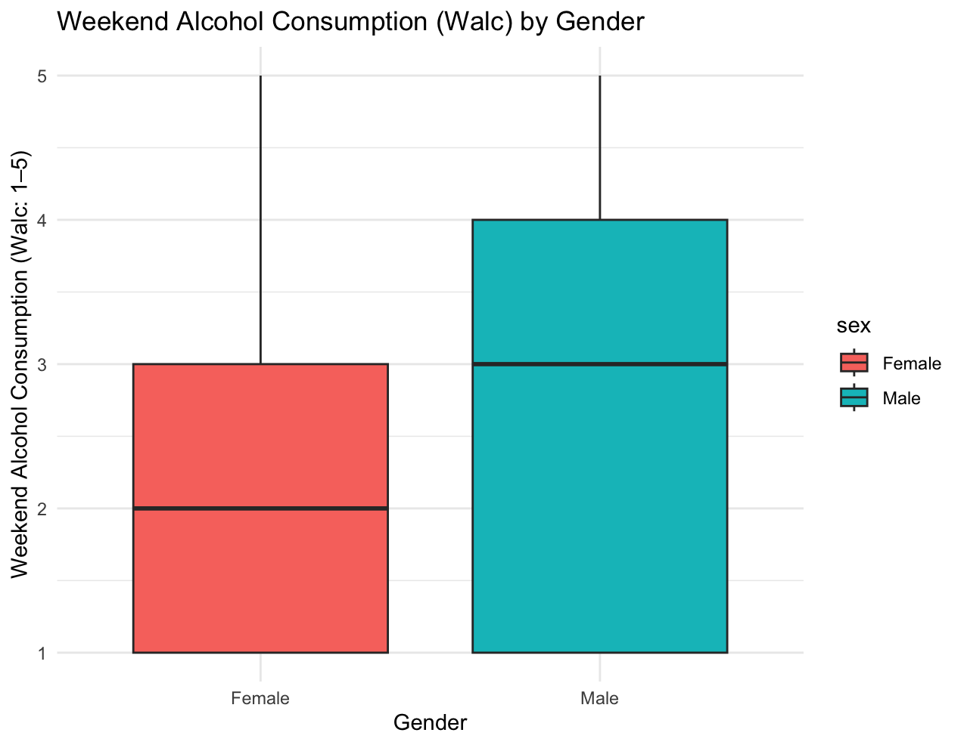

6

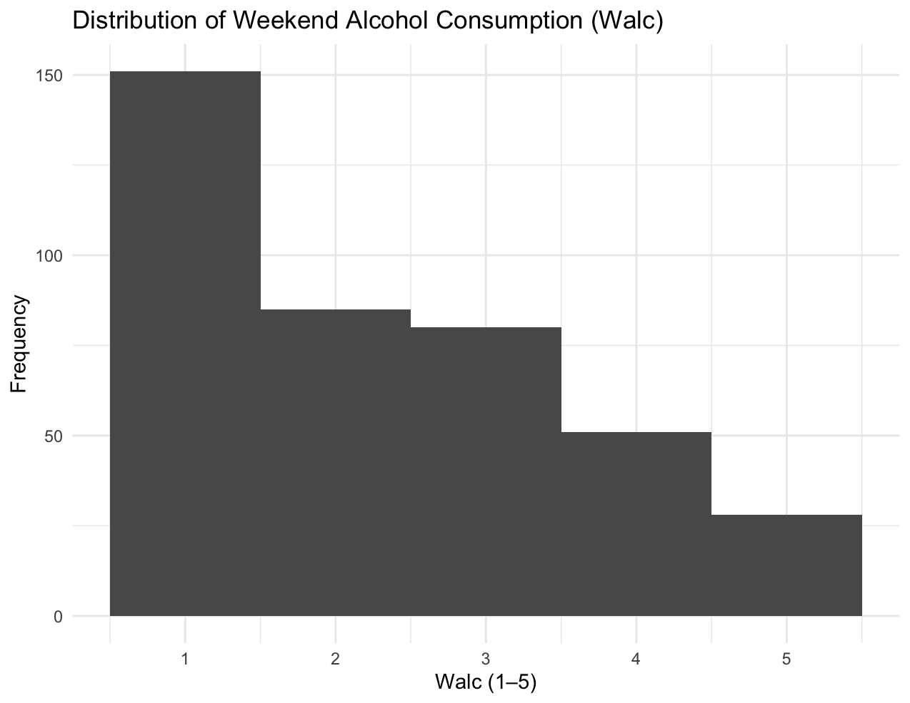

3.2 Additional information relating to understanding the data

The boxplot shows the Walc values for each gender using quartiles. It also shows how different the values are and where they might be at their highest or lowest. This is helpful for seeing how groups differ before doing inferential tests. The histogram shows how often each Walc level (1–5) occurs, which can help you figure out if the data is not normal, which is what you would expect from an ordinal scale.

3.3 Useful information for the data understanding

The boxplot shows that men usually drink more alcohol on the weekends than women do. This is shown by the higher median and wider interquartile range. The histogram shows that most students are in the lower consumption groups and fewer are in the highest groups. This suggests that the distribution is skewed to the right rather than having a normal shape.
7

4. Analysis

4.1 Statistical test used to test the hypotheses and output

We used a Welch two-sample t-test to compare the average amount of alcohol consumed on the weekend (Walc) by male and female students. This test is appropriate because it tests the mean differences between two groups that are not dependent on each other and does not assume that the variances are equal. The t-test is strong because the sample size is so large, even though Walc is measured on an ordinal scale. The analysis yielded a test statistic of t = −5.57, accompanied by approximately 341 degrees of freedom and a p-value of 5.26 × 10⁻⁸.

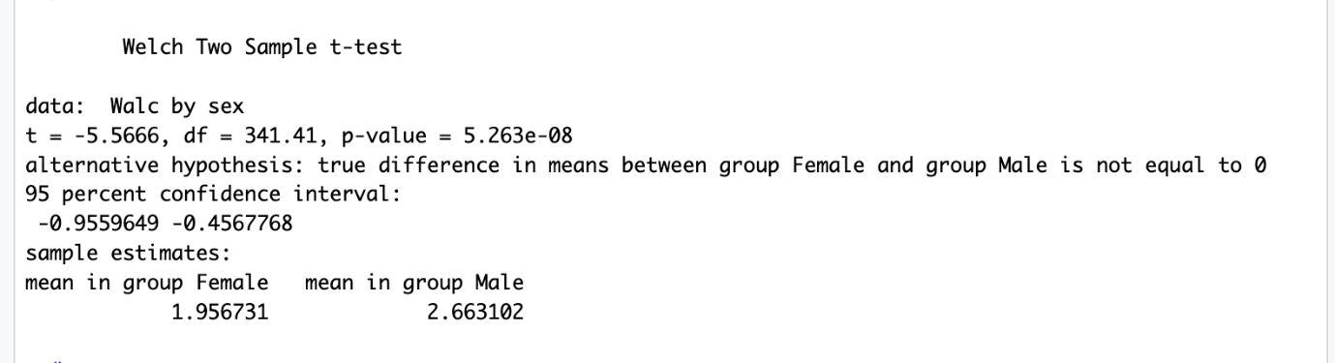

4.2 Hypothesis decision and interpretation based on the p-value

The Welch two-sample t-test results show that there is a statistically significant difference in the average amount of alcohol male and female students drink on the weekends. The p-value of 5.26 × 10⁻⁸ is much lower than the 0.05 level of significance. Consequently, the null hypothesis is dismissed. Male students indicated a greater average weekend alcohol consumption (mean = 2.66) in contrast to female students (mean = 1.96). The 95% confidence interval for the mean difference excluded zero, reinforcing the conclusion that gender is correlated with variations in weekend alcohol consumption among students.

8

5. Evaluation – Group’s Experience at 7COM1079

5.1 What went well

The group worked well together on the project, with clear communication and a fair division of tasks. Each member helped with different parts of the project, such as looking at the data, reading the literature, doing statistical analysis, and writing the report. Regular meetings helped make sure that all the sections were consistent and followed the assessment rubric. Version control and easy integration of each person's contributions were possible because everyone used the same GitHub repository. Overall, the group worked well together and stayed focused on the research question and goals.

5.2 Points for improvement

Even though working together was helpful, some parts of the project could have used more planning ahead of time. In particular, it took more time near the deadline to make sure that writing styles were the same across all sections. Future projects could be more efficient if they set clearer deadlines for each step and set aside time for final editing and proofreading. Also, peer review of statistical outputs earlier on may have cut down on the need for later changes and made people more sure of the analysis process.

5.3 Group’s time management

The group was able to manage their time well by breaking the project down into smaller tasks and giving people their jobs early. Some work, though, was done closer to the deadline than planned. Better planning of review sessions earlier in the timeline would help lower stress and give more time for improvement.

9

5.4 Project’s overall judgement

In general, the project was a success and met the learning goals of the module. The group made a clear analysis that was backed up by the right statistical methods and graphs. The project helped people learn more about data analysis, working together, and writing reports for school. It gave them useful experience that will help them in their future research and work.

5.6 Comment on the GitHub log output
The GitHub log, provided in Appendix B, demonstrates consistent engagement from all group members. Commits were made regularly and reflect meaningful progress across data analysis, visualisation, and report writing. The log provides clear evidence of collaboration, version control, and incremental development throughout the project lifecycle.
Key commits include:
- Commit Message: “Initial data cleaning and variable selection”
Established the dataset structure and prepared variables for analysis.

- Commit Message: “Added R scripts for visualisation and statistical testing”
Implemented the core analysis and generated reproducible plots and test results.

- Commit Message: “Final report editing and formatting”
Ensured consistency with the template, corrected errors, and finalised submission-ready content.

10
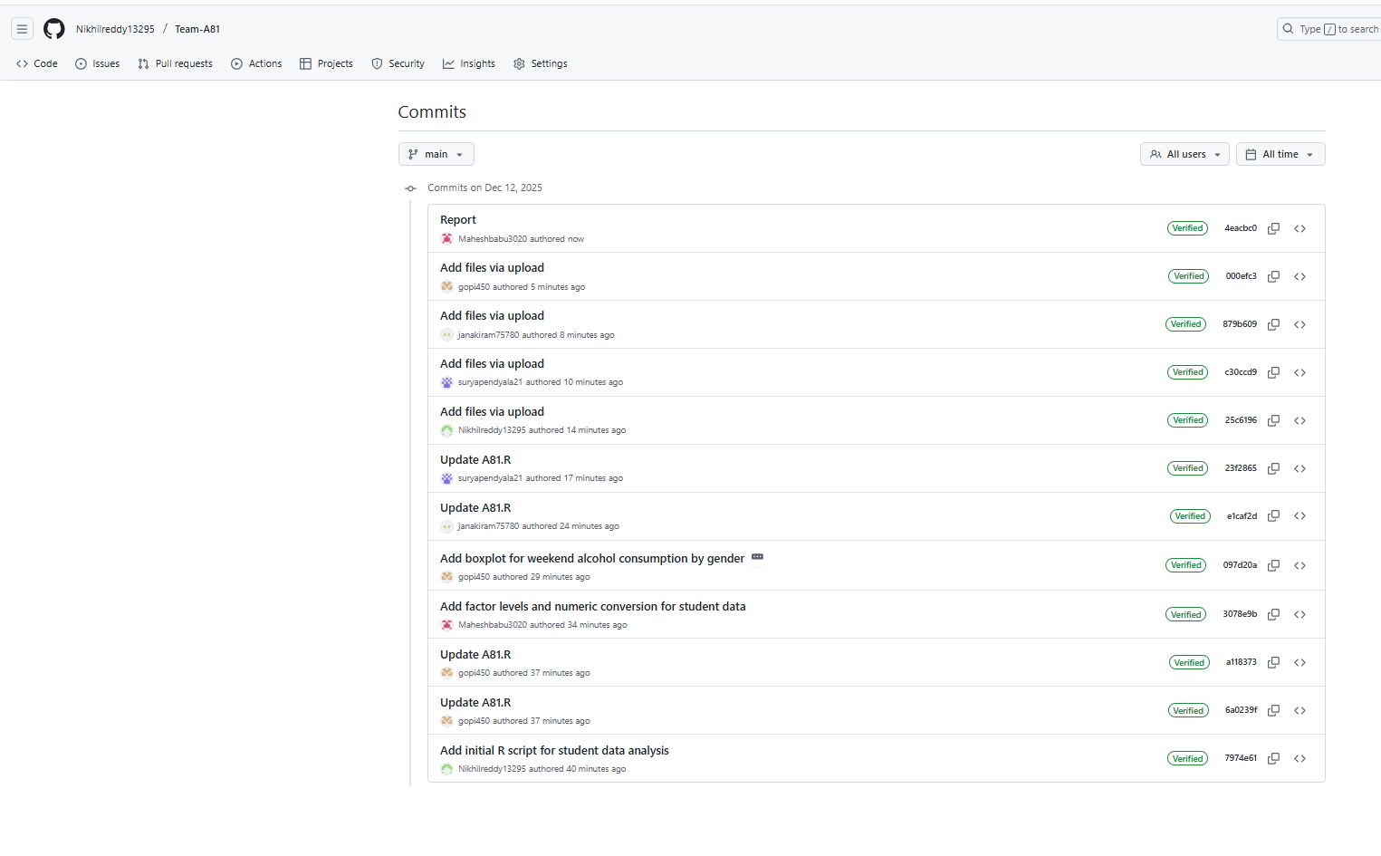

6. Conclusions

6.1 Results explained
This study found that male and female students drank alcohol on the weekends in a statistically significant way. A Welch two-sample t-test demonstrated that male students exhibited a greater mean weekend alcohol consumption compared to female students. The p-value was much lower than 0.05, which is the level of significance that shows strong evidence against the null hypothesis. These results show that gender is a significant factor related to weekend drinking behaviour among secondary school students.

6.2 Interpretation of the results
The findings indicate that male students are more predisposed to elevated weekend alcohol consumption than their female counterparts. This disparity may indicate social, cultural, or peer-related factors that influence drinking behaviour in adolescence. In a broader context these results corroborate existing literature regarding gender-specific disparities in alcohol consumption and underscore the necessity for targeted interventions to mitigate hazardous drinking behaviours among youth.
11

6.3 Implications, limitations, and future work

The research underscores the significance of gender-sensitive alcohol education in educational institutions. However, there are some problems with the study, such as the fact that it used self-reported data and a cross-sectional design, which makes it hard to draw causal conclusions. Future studies may integrate longitudinal data, supplementary social variables, and examine the effects of weekend alcohol consumption on academic performance.

7.References

Cortés-Tomás, M.T., Giménez-Costa, J.A., Motos-Sellés, P. and Sancerni-Beitia, M.D. (2017) ‘Different drinking patterns in adolescents: Gender differences’, Journal of Adolescent Health, 60(1), pp. 52–58. https://doi.org/10.1016/j.jadohealth.2016.08.019
Cortez, P. and Silva, A. (2008) ‘Using data mining to predict secondary school student performance’, in Proceedings of the 5th International Conference on Future Business Technology (FUBUTEC). Porto, Portugal, pp. 5–12.
Kuntsche, E., Knibbe, R., Gmel, G. and Engels, R. (2011) ‘Why do young people drink? A review of drinking motives’, Clinical Psychology Review, 31(5), pp. 749–761.
UCI Machine Learning Repository (2013) Student alcohol consumption data set.

12

8. Appendices
A.
library(ggplot2)
student <- read.csv("student-mat.csv", sep = ";", stringsAsFactors = FALSE)
if (ncol(student) == 1) {
student <- read.csv("student-mat.csv", sep = ",", stringsAsFactors = FALSE)
}
cat("Rows:", nrow(student), "Cols:", ncol(student), "\n")
print(names(student))
student$sex <- factor(student$sex, levels = c("F","M"), labels = c("Female","Male"))
student$Walc <- as.numeric(student$Walc)
print(aggregate(Walc ~ sex, data = student, FUN = mean))
print(aggregate(Walc ~ sex, data = student, FUN = sd))
print(table(student$sex))
ggplot(student, aes(x = sex, y = Walc, fill = sex)) +
geom_boxplot() +
labs(
title = "Weekend Alcohol Consumption (Walc) by Gender",
x = "Gender",
y = "Weekend Alcohol Consumption (Walc: 1–5)"
) +
theme_minimal()
ggplot(student, aes(x = Walc)) +
geom_histogram(binwidth = 1, boundary = 0.5) +
scale_x_continuous(breaks = 1:5) +
labs(

13

title = "Distribution of Weekend Alcohol Consumption (Walc)",
x = "Walc (1–5)",
y = "Frequency"
) +
theme_minimal()
print(shapiro.test(student$Walc[student$sex == "Female"]))
print(shapiro.test(student$Walc[student$sex == "Male"]))
tt <- t.test(Walc ~ sex, data = student) # Welch by default in R
print(tt)
mw <- wilcox.test(Walc ~ sex, data = student, exact = FALSE)
print(mw)

B. GitHub log output
14

